Introduction

The program is required to enter Leaving Cert grades for two students and calculate the points each achieved. The user is asked to enter each student’s name and enter seven grades for each student. A while loop will be used for one student, and a for loop will be used for the other. The total points will be calculated by using the best six grades, the lowest grade will not be used in the points calculation. The program will then tell the user the highest, lowest and average number of points for each student, as well as telling the user the name of the student that got the highest points score, or if both students got the same amount of points.

Steps

- Import Scanner
- Start Class
- Start Main Method
- Declare Variables
- Prompt the user for first students name
- While Loop to take in first set of grades
  - Prompt user to enter grades
  - Use an if statement to set the highest points achieved
  - Assign point values using if statement
  - Use an if statement to set the lowest points achieved
  - Set lowest value after every points achieved
  - Use else if for the remaining point values
  - Use else for last point value
  - Calculate the total points for student1
  - Increment i
  - End While Loop
- Prompt user for second students name
- Use “if(!=1)” to use input.nextLine();
- For Loop to take in second set of grades
  - Prompt user to enter grades
  - Use an if statement to set the highest points achieved
  - Assign point values using if statement
  - Use an if statement to set the lowest points achieved
  - Set lowest value after every points achieved
  - Use else if for the remaining point values
  - Use else for last point value
  - Calculate total points for student 2
  - End For Loop
- Remove the lowest score from each total
- Calculate the average for each student
- Print the results for the first student
- Print the results for the second student
- IF statement to determine which student got the highest amount of points
- Print the results
- End main method
- End class

Program Walkthrough

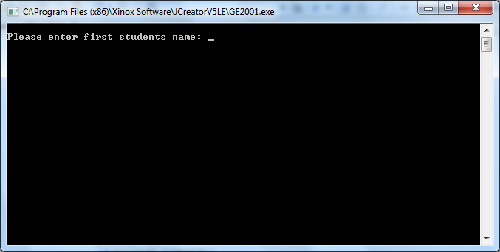
Program starts by asking the user to enter the first students name

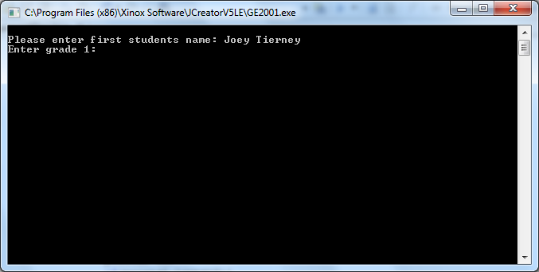
The user is then asked to enter the first grade that student one received

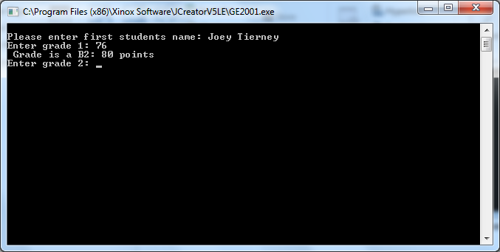
When the first grade is entered, the points of that grade are printed, and the user is asked to enter the remaining six grades.

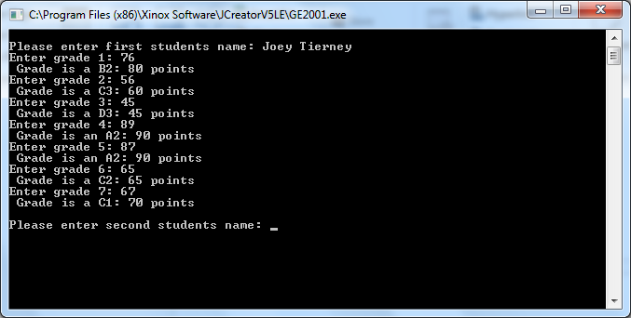
When all grades for the first student have been entered, the user is asked for the second students name

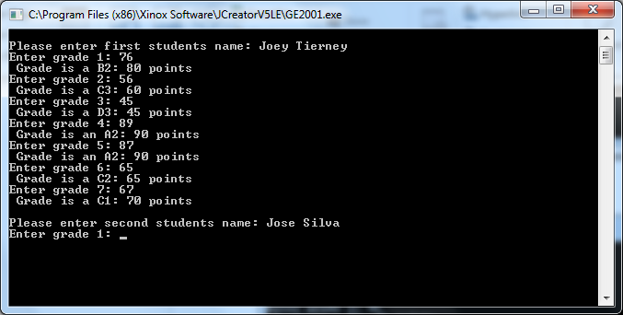
The user is then asked to enter the first grade that student two received

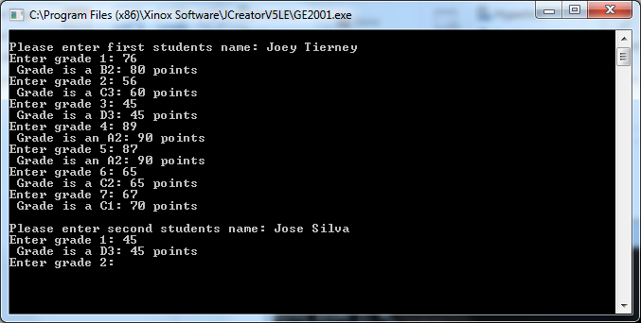
When the first grade is entered, the points of that grade are printed, and the user is asked to enter the remaining six grades.

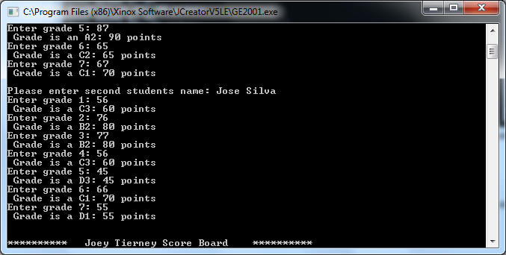
The remaining grades are printed for student 2

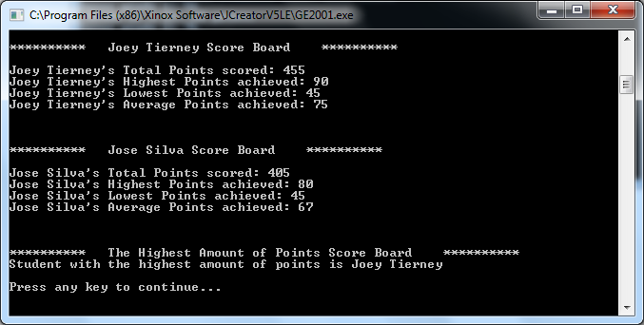
In the final result, both students total points, highest points, lowest points and average points are printed, as well as the student who got the highest amount of points between the two.

Test Bed

Scenario | Data Entered | Expected Result | Actual Result
Enter name of student 1 | Joey Tierney | Enter Grade 1 | Enter Grade 1
Enter Grade 1 | 56 | Enter Grade 2 | Enter Grade 2
Enter Grade 2 | 45 | Enter Grade 3 | Enter Grade 3
Enter Grade 7 | 78 | Enter name of student 2 | Enter name of student 2
Enter name of student 2 | Jose Silva | Enter Grade 1 | Enter Grade 1
Enter Grade 1 | 77 | Enter Grade 2 | Enter Grade 2
Enter Grade 2 | 59 | Enter Grade 3 | Enter Grade 3
Enter Grade 7 | 93 | Print total, highest, lowest and average points | Print total, highest, lowest and average points

Conclusion/Evaluation

The program essentially works, however there is a slight problem in which when the lowest amount of points are the same value (e.g. both are 45), then both of the points will be subtracted from the end total. The part of this assignment I had the most difficulty with was finding a way to assign the lowest value points to take away from the total. At the beginning, my program would only take away the 7th grade entered, no matter what the value was, this was fixed by assigning the lowest value in the if statements themselves instead of assign them outside (this may not be the most efficient way, but it works). The final testing displayed in the test bed results match perfectly with what my program is intended to do.

If I were to start the assignment again, or I had more time to work on it, I would make entering a value larger than 100 for the program to tell the user that the amount they’ve entered is an invalid number, and to re-enter it. I’d also make it so that when the lowest value is assigned to the same value of points, to add at least one of them to the total. I also think that this could be done to make the program better overall.

In conclusion, I am satisfied with how the program has turned out.

